9,101 Miles From Home
A first timer’s trip to Africa

On Feb 1st, 2025, my wife and I purchased an African Safari trip during the auction at the Rawlins County Sportsman’s Association banquet in Atwood Kansas. We were planning on a cruise to Alaska this year anyway, why not go to Africa instead. The trip was donated by Piet Steyn, the owner and operator of Safari Njema and it was for an Impala and a Wildebeest. The next day, we met with Piet at our house to plan the trip. We decided to go from October 1st through the 8th. We talked about all the things that will happen, expectations, taxidermy, and other subjects. Piet said to take at least $600 USD for tips as American money is preferred. We were going to extend for a couple of days to go to Pilanesberg National Park to see more wildlife. We should be able to see elephants and all the cats there. Turns out that the time of year we are going is the busy season and the rates are very high, so we later decided not to go to Pilanesberg. Piet said that he has a .375 H&H Mag in camp that I could use for the hunt if I did not want to take my own gun. If you do want to take your own firearm, he recommends a 3rd party service that will complete all the paperwork for you so that you can import and export the firearm with ease through South Africa.
Every year, usually in the spring/early summer, we go on a vacation with my wife’s brother Clayton and his wife Amy. I thought that this would be a really fun trip and we decided to invite them along. We made the call and apparently, they had a trip already planned with all their children to New Mexico. They said to give them a day and they would call us back. Apparently, going to Africa was a bit too hard to turn down.
The first hurdle was finding flights that arrive on October 1st. This is a bit difficult and confusing as the airlines sometimes don’t have the date you arrive on the screen when looking at flights, due to crossing the international timeline. If you wanted to split up your time in an airplane, there is going to be a 4-to-10-hour layover somewhere across the Atlantic Ocean in England, Germany, Turkey, Qatar or France. Amy found a flight on United that goes from Newark to Johannesburg South Africa that is in the air for about 16 hours in a Boeing 787 Dreamliner. We both booked the same flight.
I have a friend that is a taxidermist that lives by Longmont Colorado. Kimmel Evans with EchoHawk Taxidermy produces fantastic work and makes sure the details are perfect. He does a lot of African mounts for clients, and I trust him with any kind of taxidermy work. Kimmel said that the hunter needs to be their own advocate and make sure their game is handled properly. He suggested we set the importing up with D&L Customs Broker House, an import company out of the Chicago area. They specialize in FDA and hunting trophies from other countries. When I called the company to set up an account, they had a packet of information they emailed me that included a hunter information packet and a customs power of attorney. This allows them to receive customs items on your behalf. They can then ship the capes and hides to your tannery and/or taxidermist. It was a very simple process and the people at D&L were very helpful. Kimmell said that you don’t need to bring back what is called the back skin of the animal, leave it in South Africa. We did bring back a back skin which you find out later as to why. He also said that they overboil the heads and sometimes lose teeth in the water. Make sure you get all your teeth back.
In the months leading up to the trip, I looked at a lot of online stories, forums and spoke with several people that have been on an African Safari. What do you wear, what tech goodies do you need, do you need shots, what kind of boots should you wear? It turns out that hindsight was 20/20 on all those things. Ask your guide on his recommendations as they know the land. Laundry in camp was done every day so you only need 3 sets of clothes. As far as color and type of clothing, wear cotton or something fairly durable. Piet mentioned thorns, we will get to that later. The best shirt that I took was a green 5.11 tactical TacLite Pro shirt. I also have a tan one that I took but when you are out stalking an animal that will run when it sees you, green blends in with the trees and bushes much better than tan or other colors. OD green or similar shade is the best. For boots, I bought a pair of Danner Fullbore warm weather boots. On some of the forums I was looking at, they said to get a pair of gators to go over the tops of your boots to keep thorns, weeds and critters out. I found some Kenetrek gators on Amazon that I thought would work. They were fine, but were much taller than I needed and had a strap on the top that went around the leg just under the knee. The strap really needed to be elastic, rather than fixed. We also bought a good lithium battery bank to take with us to charge phones, laptops, earphones and camera batteries. It did come in handy. In the hotel we stayed at near the Johannesburg airport, there were USB ports that only put out 5 watts of power and there were also power strips at camp that had USB 5w outputs. If you want to plug into an outlet, you would have had to use a power converter to go from the South Africa plug to an American style plug that drops the voltage from 220V to 110 volts AC.
September 2025. Getting close to lift off. Piet emailed to confirm that everything is a go and to see if we are still planning on coming. We decided to take $1000 each in cash for incidentals and tips to the trackers, cooks, maids and others.

My wife and I went and looked at some African taxidermy at a local guy’s house to see the differences in some of the animals and how we might want them done. He mentioned that we should take an extra suitcase with us to bring back goodies that we might buy along the way. We could fill it with clothes that one might take goodwill and give them out to the local tribal children. It turns out that we only bought one item and never got to interact with any local families. The extra suitcase let us lighten the load in our main suitcase and our carry-on bags on the way back. It worked out well because our main suitcase would fit inside the extra one we took so it looked like we only had one bag to check in on the way over.
Travel time on the way over was about 40 hours from the time we left home. We flew from Denver to Newark and then to Johannesburg. The 16-hour flight was terribly long, but worth it. The new 787 Dreamliners have electronic window shades that were kept dark by the crew so you had the perception of night for the whole trip, with the last hour being “opened” so you had daylight right before we landed. We took off from Newark at about 9:50pm and landed in South Africa at 6pm. This really skewed your perception of how late in the day it was. The meals on the flight were actually fairly good.
Since preparation for a trip usually dictates how well the trip goes for you, you must also manage expectations on what the unknown might be. We knew that travel time would be very long and the time difference would not be insignificant. I had preconceived expectations on what we might see while traveling 8 hours from the airport to camp, and for the most part, it was what I was thinking. The biggest thing that caught my attention was how trashy the lower income area of the country would be. The locals will just dump their trash over their fence or across the street. While at camp, it was extremely clean and well taken care of.
Once we crossed the gate to the hunting camp, it was like a transformation to a clean, stable and wild environment. Safari Njema operated out of a hunting concession that encompasses over 5400 acres with the far corners being around 5.5 miles apart. The elevation at camp is right at 3257 feet which is very close to home. Since October in South Africa is the start of their spring, it was fairly warm with temps while we were there ranging from highs in the mid 80’s to mid 90’s. Lows were very nice from around 60 to low 70s. The humidity was usually in the teens during the day. On the first day, we got to camp around 1pm or so and waited until later in the day to go out and see things. We ended up going after an impala for me to shoot but the impala didn’t find out about it. I quickly realized that Patrick, our tracker, was a man with incredible skill. This man can discern how old a track is that is on top of other tracks, on top of other animal tracks. The sand there was marked everywhere with tracks. It was an amazing thing to see him work.
The area we were in is the southern portion of the Kalahari Desert, a semiarid sandy savanna covering 350,000 square miles. The landscape is dotted with Acacia trees and wait-a-bit bushes. You have to be very careful when walking around. Some of the thorns on the Acacia trees were over 2” long and the thorn bushes have ¼” thorns on them that are hook shaped and will rip and tear your skin and clothes if you are not careful. Almost every time we went into the bush to track an animal we came back bloody, but it was blood that we earned trying to keep up with the tracker.

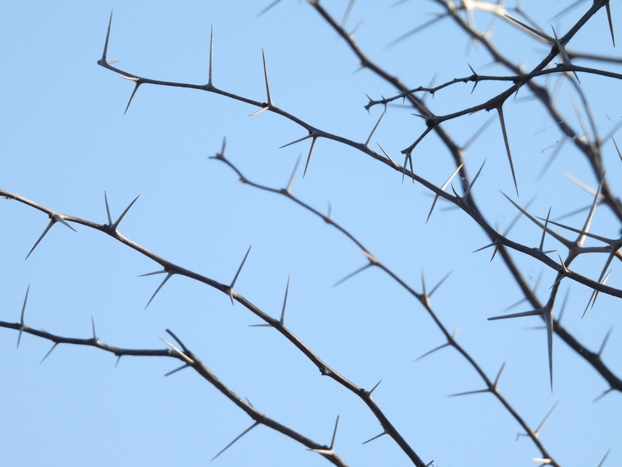

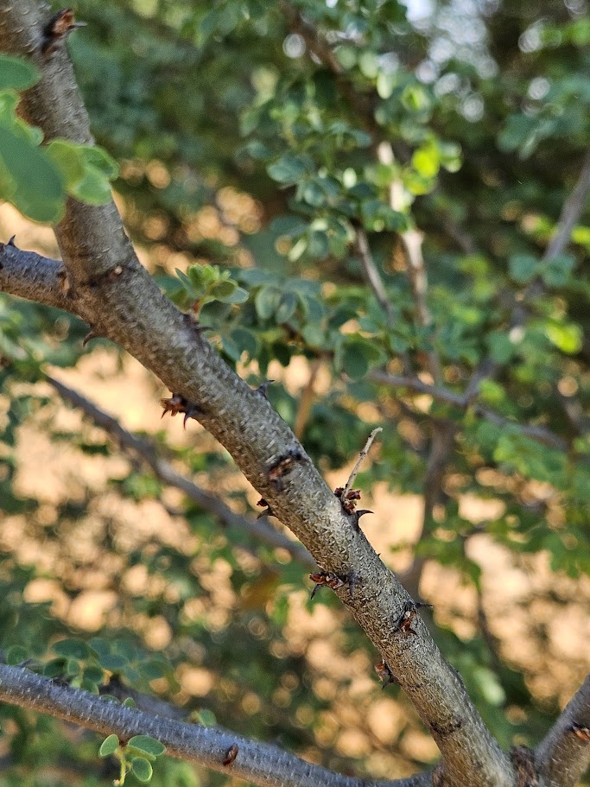

On the 2nd day, Piet told me that if I wanted, I could trade out an impala for a blesbok. I took him up on the offer and shot a very nice example of a common Blesbok that scored 46” Safari Club International measurement.

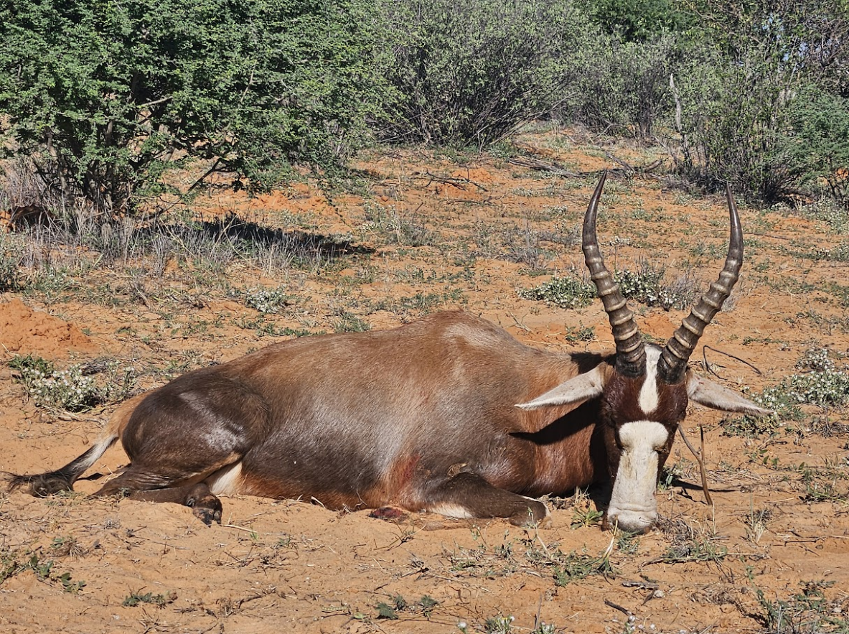
Here is where things went south for me. We saw some wildebeest one day and decided that was the thing to go after. After a nice stalk, we found ourselves with a good wildebeest bull about 65 or so yards away. It was grazing from our right to left in a very small opening. It heard or saw us and turned to face us. I put a shot from the .375 in what I thought was the center of his chest. He must have been turned slightly, and the bullet must have ranged just under the shoulder and along the rib cage. We had a very small blood trail from the entrance wound. The tracker could tell right away that I hit it off center. We tracked that critter for about 5 miles, eventually losing the blood trail, and the animal. Nothing is guaranteed in hunting. There is a reason why they call the wildebeest a poor man’s cape buffalo. You pay for the privilege of putting a bullet into one, not to take it home.
Speaking of Cape Buffalo, we ran across them several times while we were off of the vehicle while tracking game. They were usually around 50 yards or so away and we stopped very quickly when we saw they were in front of us. They would always stare at us for a while and turn away. It was very cool to see them up close and only slightly comforting to have a .375 H&H Mag in your hands.
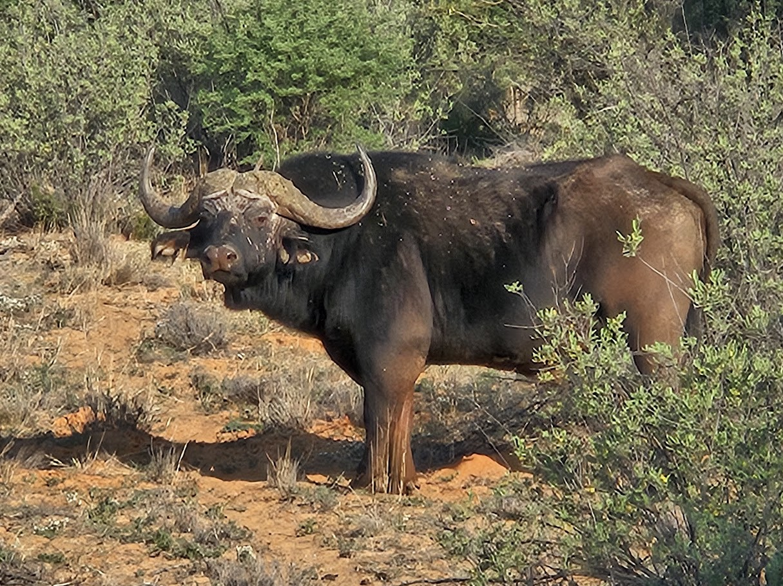
I felt bad that we were leaving Clayton out of the hunting adventures. He wanted to get a Kudu and a Zebra. If we couldn’t get one of them, he would take a Giraffe. It turns out that the Kudu and Zebra are one of the hardest to hunt animals that he could have picked from. There was only one time that we saw a zebra standing still. They tracked one for miles and never got a shot off at one. Clayton changed his mind and went for a giraffe next. The giraffe must have found out that they were going to be targeted and hid from us for quite some time. Finally, we found some and had one on the ground fairly quickly. It was amazing to see one of these animals up close. They are huge!

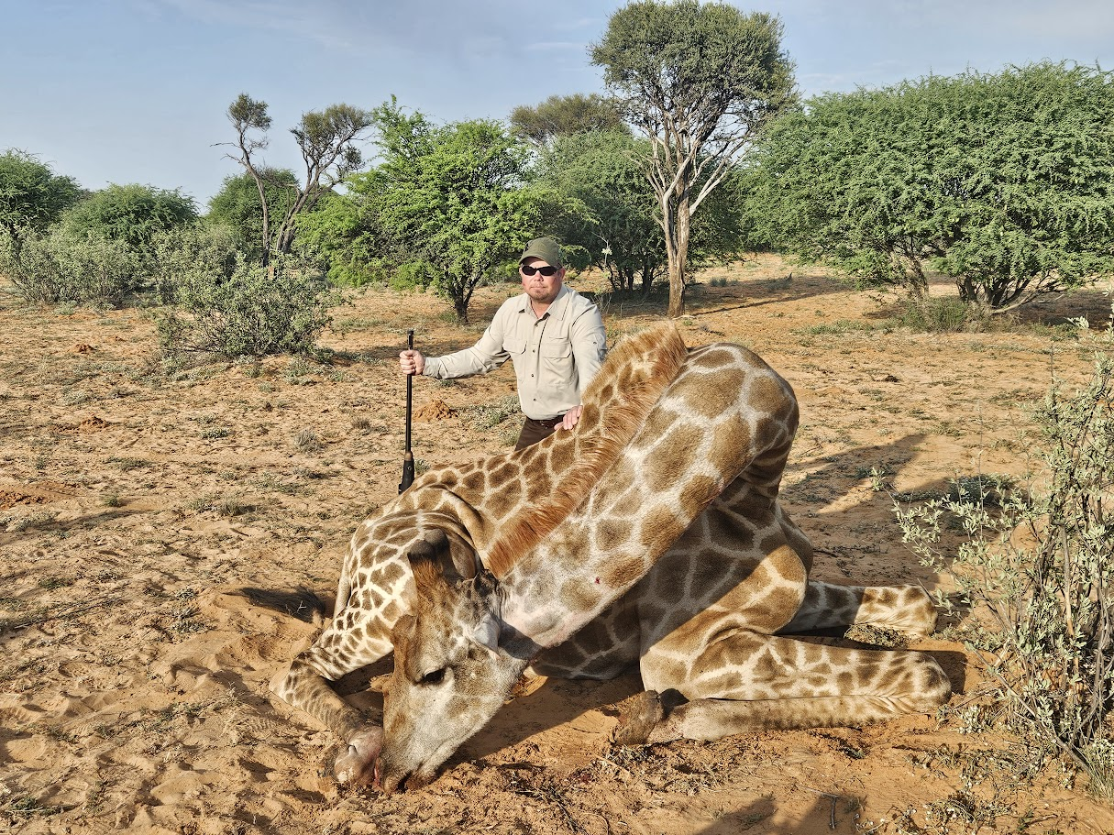
It took the trackers and skinners about 2 hours to have the animal cut up and on the way back to camp. I took a lot of pictures of them cutting up the giraffe but they are too graphic to show here. Let’s just say that it was very impressive to see the process when all I have been around was a bunch of deer, antelope and an elk. Clayton intends on having the giraffe mounted as a shoulder mount on his wall. Yes, he has a vaulted ceiling. He will also get quite a bit of the giraffe back from Africa, including the skull, front half cape, leg bones, hooves and “socks” and the back skin which he intends on doing some sort of artwork with.
Piet asked if I wanted to shoot anything else and I just happened to buy an impala. We found a herd of them that was kind enough to stand still and I had one on the ground quickly. The impala I shot happened to be a very nice specimen with 24” horns that scored 59” SCI scoring. This should put it in the bottom of the gold class tier. It is a very nice example of a common impala.

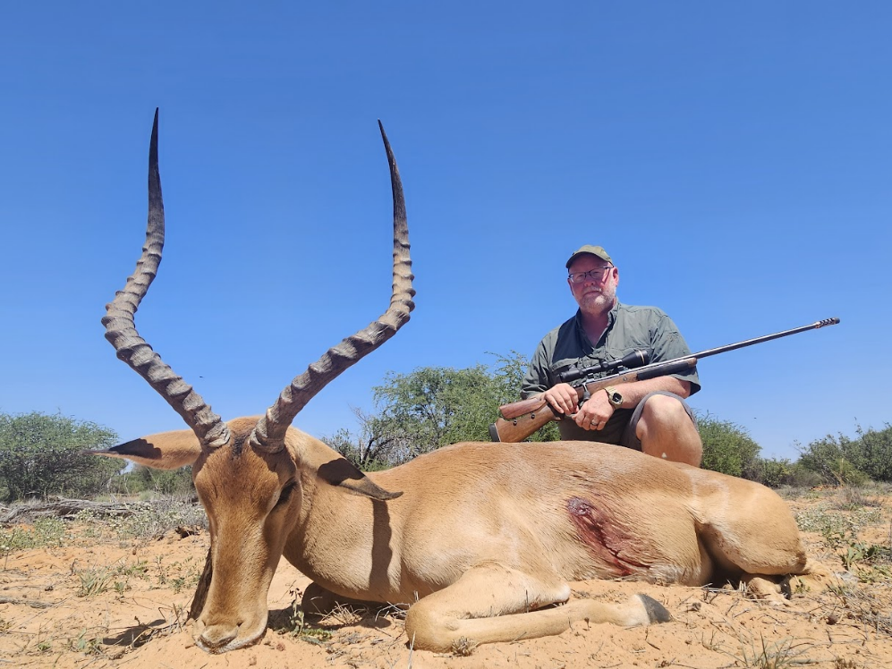

Piet had his fiancé’s youngest son Juhan with us as an apprentice for the entire trip. We were very happy to have him along and he shot a nice blesbok for himself. Juhan is a very nice young man and is well on his way to be a very good guide and host.

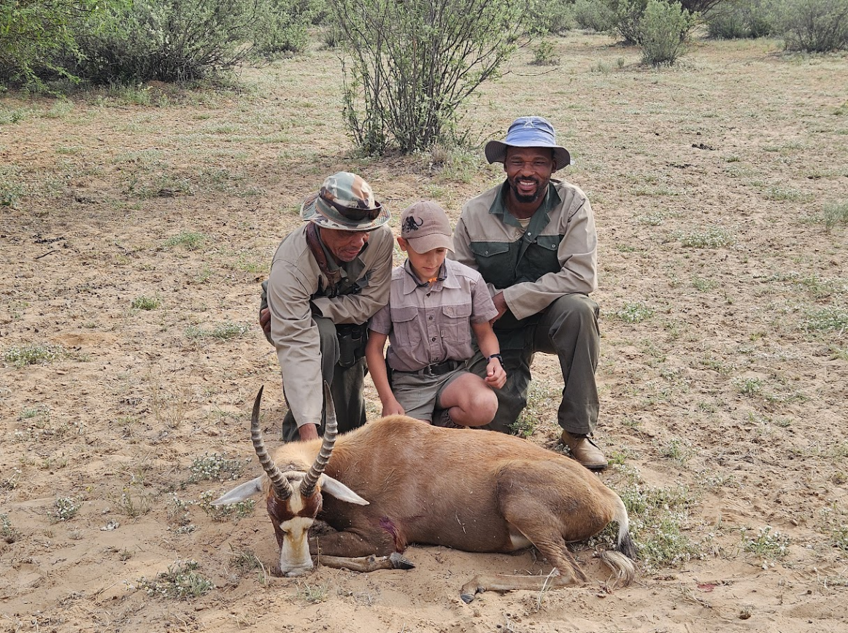
We got back on track looking for a Kudu for Clayton. This was much easier said than done. When we found them, they were some young bulls and not worth going after. Some nice bulls were finally located, and the hunt was on. We waited on the vehicle for quite a while during the time they were tracking down the Kudu to get a shot. Finally, we heard a shot in the distance, actually, I heard the impact of the bullet and then the shot immediately after. I was sure the animal was closer to us than Clayton was. Shortly after, we heard the radio call to come to the kill site. Clayton connected with a nice Kudu with one shot from the .375 H&H Mag.

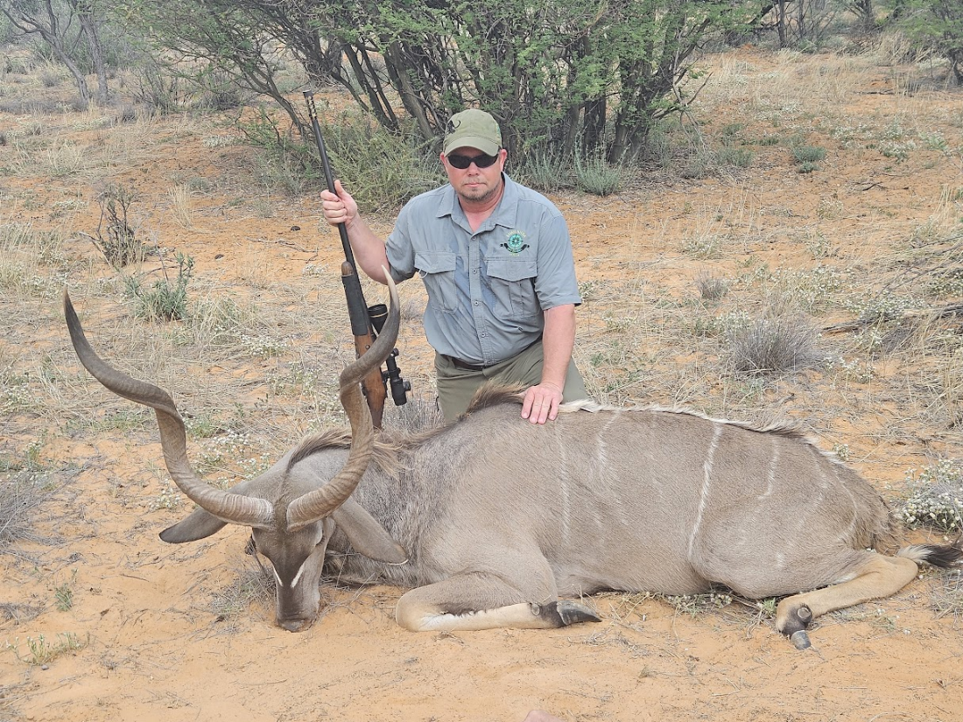

After the Kudu, we were free to do whatever we wanted. The wives wanted to be driven around to take time to take pictures of whatever they wanted. They took up residence on the front bench of the safari vehicle for the next couple of days, taking pics of the wildlife. Amy is a very accomplished photographer and took some stunning pictures of the local flora and fauna. Some of the animals we saw on the trip included: Baboon, Vervet Monkey, Blesbok (common and white), Cape Buffalo, Eland, Gemsbuck, Giraffe, Wildebeest (blue, golden and black), Duiker, Impala, Kudu, Letchwe, Nyala, Ostrich, Red Hartebeest, Sable, Springbok, Zebra, Meerkat, Bat Eared Fox, Mole Snake, Kori Bustard, Southern Yellow-Billed Hornbill, African Grey Hornbill and numerous other birds and insects that are endemic to South Africa.

The food that was served in camp was very good and consisted of some local or at least generally South African dishes. Some of the meat we tried ranged from beef steak to blesbok, giraffe, wildebeest and zebra. The local deserts were wonderful. The chef made a dessert that roughly translated to pumpkin fritters that were absolutely delicious. You can bet we will be trying them at home. The laundry was done every day in the morning and back in our room by the time we got back from the hunt before supper. The clothes were clean and folded perfectly. The entire camp was very nice, clean and quiet. One morning before sunrise, I was sitting on the front porch area of the lodge drinking coffee with Piet and heard Jackals howl in the distance, sounding fairly similar to our local coyotes. The days were laid back with the hunt starting at about 6:30am or so and we would arrive back to the lodge around noon for lunch at 1pm. We would have a siesta after lunch and go back out around 4pm or so. This would differ depending on the time of year and moon phase while you are there. Piet said that the optimal time of year for hunting would be March to May on a new moon.
The trip back to the states was another long and tiring trip. I was awake for about 45 hours from when I woke up at camp until I crashed after I got home. I would absolutely do it again and we plan to go back in a few years. There are a lot of things that I left out of this article, such as the history and political issues that South Africa has at this time. Those conversations are much better had with those that are affected by them. Piet and Collett, his fiance, have no problem talking about the issues that they face. They are a great couple with a great business and we shared a lot of stories and laughs during our time there. If you have the means to go, you will be glad you did.

Jim Engel

© 2025 Jim Engel

This article may not be reproduced in part or in full without the express written permission of the author.

